The U-Net architecture is a popular neural network design for image segmentation tasks, and it's known for its efficiency and effectiveness in capturing both high-level and low-level features in images. Here’s a detailed breakdown of its architecture and workflow:

**U-Net Architecture**

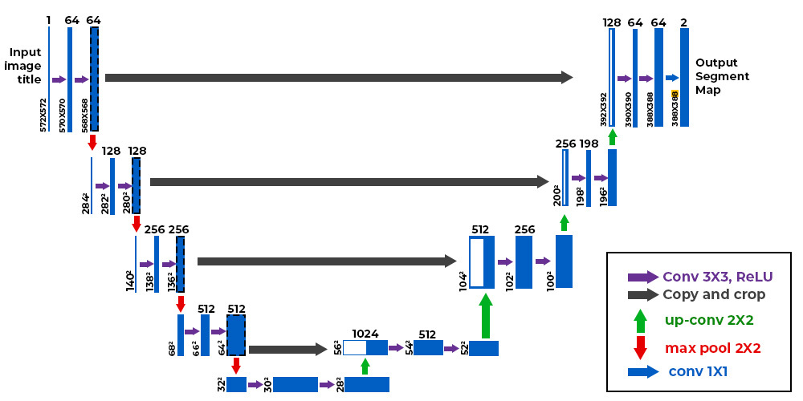

1. **Contracting Path (Encoder):**
   * **Downsampling Blocks:** The contracting path consists of a series of convolutional layers followed by max-pooling layers. Each block typically includes two convolutional layers (with small 3x3 filters) followed by a ReLU activation function.
   * **Pooling:** After the convolutions, a max-pooling layer (usually with a 2x2 filter) reduces the spatial dimensions of the feature maps. This process is repeated several times, allowing the network to capture high-level features and reduce the dimensionality of the data.
2. **Bottleneck:**
   * **Bridge:** At the bottom of the contracting path, there’s a bottleneck layer where the feature maps are at their smallest size. This part usually consists of several convolutional layers, helping the network capture the most abstract features.
3. **Expansive Path (Decoder):**
   * **Upsampling Blocks:** The expansive path mirrors the contracting path. It involves upsampling layers (using transposed convolutions or upsampling followed by convolutions) that increase the spatial dimensions of the feature maps.
   * **Skip Connections:** The key feature of U-Net is the use of skip connections, which concatenate the feature maps from the contracting path with those from the corresponding layer in the expansive path. This helps the network retain spatial information that might otherwise be lost during downsampling.
4. **Output Layer:**
   * **Final Convolutions:** After the upsampling, the final layer is a 1x1 convolution that reduces the number of channels to the desired output size (e.g., the number of classes in segmentation tasks).

**Model Workflow**

1. **Input:** The network takes an input image and processes it through the contracting path to capture various levels of features.
2. **Feature Extraction:** The encoder extracts features at different resolutions, with the features becoming increasingly abstract as they move deeper into the network.
3. **Contextual Information:** The bottleneck captures the most abstract features, providing context for the decoding process.
4. **Feature Restoration:** The decoder uses the skip connections to restore spatial information while gradually upsampling the feature maps.
5. **Segmentation Map:** The final output layer produces the segmentation map, which can be used for tasks like image segmentation, object detection, or enhancement.

**Key Points**

* **Skip Connections:** These are crucial as they help the network combine low-level information from the encoder with high-level information from the decoder, improving the accuracy of the segmentation.
* **Symmetry:** The architecture is symmetric, with the contracting and expansive paths having similar structures but in reverse order.
* **Performance:** U-Net has been shown to perform well in various medical imaging and other image segmentation tasks due to its ability to capture fine details and contextual information.

**Links:**

<https://www.youtube.com/watch?v=oQxrjl3INEY>

<https://www.youtube.com/watch?v=szZ71VTLB-U>